**ORGANIC FARMING**

**A MINI PROJECT REPORT**

**18CSC305J - ARTIFICIAL INTELLIGENC**

***Submitted by***

**VIGNESH[RA2111047010204]**

**MIDHUN [RA2111047010205]**

**GOWTHAM[RA2111047010234]**

*Under the guidance of*

**Dr. Pritam Khan**

Assistant Professor, Department of Computer Science and Engineering

***in partial fulfillment for the award of the degree***

***of***

**BACHELOR OF TECHNOLOGY**

in

**COMPUTER SCIENCE & ENGINEERING**

of

**FACULTY OF ENGINEERING AND TECHNOLOGY**



S.R.M. Nagar, Kattankulathur, Chengalpattu District

**SRM INSTITUTE OF SCIENCE AND TECHNOLOGY**

(Under Section 3 of UGC Act, 1956)

**BONAFIDE CERTIFICATE**

Certified that Mini project report titled “Organic Farming ” is the bona fide work of MIDHUN (RA2111047010204), VIGNESH (RA2111047010205), GOWTHAM [RA2111047010234] who carried out the minor project under my supervision. Certified further, that to the best of my knowledge, the work reported herein does not form any other project report or dissertation on the basis of which a degree or award was conferred on an earlier occasion on this or any other candidate.

**SIGNATURE**

Dr. Pritham Khan

Assistant Professor

CINTEL

**ABSTRACT**

Agriculture serves as the cornerstone of the Indian economy, contributing significantly to its GDP, with the current share standing at 17%. However, the sector faces formidable challenges, including crop failures arising from the erroneous selection of crops for cultivation. Such failures not only jeopardize the agricultural sector's stability but also precipitate a decline in GDP contribution. To mitigate this risk and bolster agricultural productivity, a transformative initiative is proposed: the development of an intelligent AI-based system tailored to predict the most suitable crops for specific fields.

This project harnesses cutting-edge technologies, including machine learning, data analysis, and artificial intelligence, to synthesize a comprehensive understanding of various factors influencing crop selection. By integrating soil quality assessments, climate condition analyses, historical crop performance data, and real-time market trends, the system aims to furnish farmers with precise recommendations tailored to their unique agricultural contexts. Moreover, advanced features embedded within the system seek to empower farmers with actionable insights and tools aimed at optimizing crop yield rates.

By fostering informed decision-making and enhancing agricultural efficiency, this initiative aspires to catalyze a paradigm shift in Indian agriculture, ushering in an era of sustainable growth, resilience, and prosperity for farmers and the nation at large

**ABSTRACT iii**

**TABLE OF CONTENTS iv**

**LIST OF FIGURES v**

**ABBREVIATIONS vi**

**1 INTRODUCTION 7**

**2 LITERATURE SURVEY 8**

**3 SYSTEM FLOW CHART AND DESIGN 9**

**4 METHODOLOGY 10**

4.1 Data Science **10**

4.2 Machine Learning **11**

4.3 KNN **12**

4.4 Random forest **13**

4.5 IMPLEMENTATION OF MACHINE LEARNING ALGORTHMS **14**

**5 CODING AND OUTPUT 15**

5.1 PROGRAM WITH OUTPUT OF KNN ALGORITHM **15**

**5.2** PROGRAM WITH OUTPUT OF RANDOM FOREST ALGORITHM **16**

5.3 EVALUVATION AND ANALYSIS BETWEEN THE ML ALGORITHMS **17**

Random Forest Algorithm KNN Alogrithm

**6 CONCLUSION 18**

**7 REFERENCE 19**

3.2.1 FLOW CHART 9

4.3.1 REPRESENTATION OF KNN 12

4.4.1 REPRESENTATION OF RF 13

5.3.1 CONFUSION MATRIX OF RF 17

**5.3.2** CONFUSION MATRIX OF KNN 17

5.3.3 GRAPH BTW PARAMETERS FOR RF AND KNN 1

**ABBREVIATIONS**

|  |  |
| --- | --- |
| **IOT** | Internet of Things |
| **KNN** | K-nearest neighbor algorithm |

|  |  |
| --- | --- |
| **RF** | Random forest algorithm |
| **NKP** | nitrogen (N), phosphorus (P), and potassium (K) |

**INTRODUCTION**

Agriculture is the lifeblood of India's economy, intricately woven into the fabric of its society and sustenance. With over half of its population engaged in agricultural pursuits, the sector forms the bedrock of livelihoods across the nation. Beyond mere economic significance, agriculture embodies a way of life, providing food security, shelter, and employment opportunities to millions. India's agricultural landscape is as diverse as its people, encompassing a rich tapestry of crops and cultivation practices.

Renowned globally as the largest producer of staple crops such as wheat and rice, as well as commodities like sugarcane, dry fruits, and coconut, India's agricultural prowess is unparalleled. This abundance not only fulfills domestic demand but also fuels international trade, bolstering the nation's position in the global market.

Despite the rapid modernization and industrialization witnessed in other sectors, agriculture remains steadfast, contributing approximately 16% to India's GDP. This steadfastness underscores the sector's resilience and adaptability in the face of changing socio-economic landscapes.

As India strides forward into the future, the significance of its agricultural sector cannot be overstated. Sustainable agricultural practices, technological innovations, and inclusive policies will be imperative in ensuring food security, rural development, and economic prosperity for generations to come. The trajectory of India's future is undeniably intertwined with the fate of its agricultural sector, making its continued growth and vitality paramount for the nation's overall well-being.

**LITERATURE SURVEY**

|  |  |  |  |  |
| --- | --- | --- | --- | --- |
| SI.NO | TITLE OF THE  PAPER | AUTHOR NAME | INFERENCE | JURNAL NAME AND YEAR |
| 1 | Intelligent crop  Recommendation system using MI | A.Priyadharshini et al | learned to use soil and climate factor for prediction of plant. | IEEE-2021 |
| 2 | Crop Yield  prediction  Using MI  algorithms | Dr.M.Rudra kumar et al | Learned to create a MI algorithm to  predict the plant. | IEEE-2021 |
| 3 | Crop selection  using data  Analytics | Manish kumar  sharma  et al | Learned the  accuracy of the prediction of the plant. | IEEE-2021 |
| 4 | The Prototype of Decision Support System For  Selecting The  Lands of Crops | Dema Mathias  Lumban Tobing  Et al | Learned how to  use Using decision support system,  resulting in a  choice of land  alternatives in the ranking system | IEEE(2019) |

Crop Selection System:

● Existing project works only based on the soil type and rainfall

● This will lead to wrong prediction because many aspects are required for the growth of plant.

● In existing project many focused on some basic plants

● The accuracy rate is very low.

● In existing project they have not checked the

○ Intensity of Sunlight

○ Groundwater level

○ Nutrients

○ Weather

○ availability of seeds

○ fertilizers to be used

❖ We are going to add these requirements to predicate the crop

**SYSTEM FLOW CHART AND DESIGN**

**FLOW CHART**

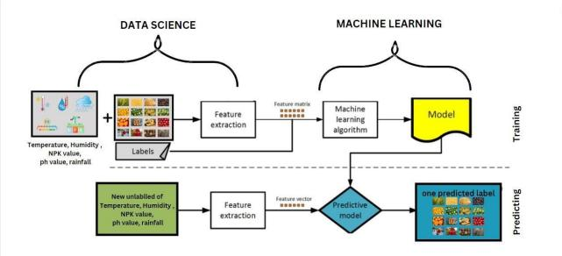

• Prepare labeled datasets for each crop with input features: humidity, temperature, time, NPK value, and

rain.

• Perform data preprocessing steps: handle missing values, remove outliers, and normalize or scale input

features if necessary.

• Split the labeled dataset into training and test sets using the train_test_split function.

• Train separate KNN models for each crop using the labeled training data.

• Make predictions on the unseen data in the test set for each crop using the trained models.

• Assign predicted crop labels to the data points in the test set.

• Evaluate the performance of the models for each crop by comparing the predicted crop labels with the

actual labels in the test set, calculating evaluation metrics like accuracy, precision, recall, and F1 score.

**METHODOLOGY**

**4.1 DATA SCIENCE**

1. Data Collection

• Identify and select relevant data sources, such as databases, APIs, or data files.

• Ensure data collection covers necessary features and labels for effective model training.

• Consider factors like data quality, relevance, and representativeness.

• Gather a diverse and representative dataset to capture variations and patterns in the problem.

2. Data Preprocessing:

• Transform raw data into a suitable format for analysis and model training.

• Handle missing values, outliers, inconsistent formatting, and noise.

• Apply techniques like imputation, outlier detection, feature normalization, and encoding for categorical

variables.

• Enhance data quality and consistency to improve the performance of machine learning algorithms.

3. Scaling:

• Trasform numerical features to a standard scale.

• Scale features to a specific range, such as [0, 1] or [- 1, 1].

• Use scaling techniques like Min-Max scaling or Standardization.

• Eliminate the influence of different scales on learning algorithms, especially for distance-based or

gradient descent-based methods.

**4.2 MACHINE LEARNING**

Machine learning is a method of teaching computers to learn from data, without being explicitly programmed. It involves using algorithms to identify patterns and make predictions or decisions based on input data. Common applications include image and speech recognition, natural language processing, and predictive modelling.

1. Model Selection:

Choose an appropriate machine learning algorithm for crop selection. This can include decision trees, random

forests, support vector machines, or neural networks. Consider factors such as the type of data, problem complexity, interpretability, and computational requirements when selecting the model.

2. Model Training and Evaluation:

Split the dataset into training and testing sets. Use the training set to train the selected machine learning model

using the chosen algorithm. Evaluate the model's performance on the testing set using evaluation metrics like accuracy, precision, recall, and F1 score. Fine-tune the model parameters to optimize its performance.

3. Predictive Analysis:

Use the trained model to make predictions on new, unseen data. These predictions can suggest suitable crop

choices based on input features such as temperature, rainfall, soil pH, market demand, and other relevant factors. The model's predictions can aid in decision-making for crop selection.

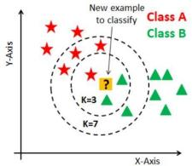

**4.3 K-Nearest Neighbour (KNN) Algorithm**

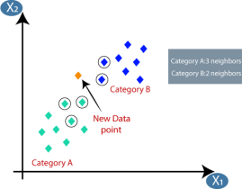

The K-Nearest Neighbors (KNN) algorithm is a simple yet effective machine learning algorithm used for both

classification and regression tasks. It is a non- parametric algorithm that makes predictions based on the similarity between the input data and its neighbouring data points.

In KNN, the value of K determines the number of nearest neighbors to consider for prediction. Given a new data

point, KNN identifies the K closest data points in the training set based on a distance metric (e.g., Euclidean distance). For classification, the majority class label among the K neighbors is assigned as the prediction for the new data point. In regression, the average value of the K nearest neighbors is used as the prediction (as shown in fig 4.3.1).

KNN is a lazy learning algorithm, as it does not explicitly learn a model during the training phase. Instead, it

stores the training data in memory and calculates predictions at runtime. This allows KNN to adapt well to new training data without retraining the entire model. However, it can be computationally expensive for large datasets.

**4.4 Random Forest Algorithm**

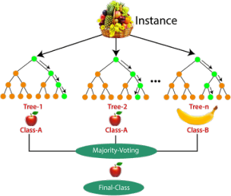

Random Forest is amachine learning algorithm that combines the predictions of multiple decision trees to make

accurate predictions. It is an ensemble learning method that improves upon the performance of individual decision trees. Random Forest works by creating a forest of decision trees, where each tree is trained on a random subset of the training data. At each split in the tree, a random subset of features is considered, which helps to increase diversity and reduce correlation between the trees.

To make predictions, each tree in the Random Forest independently classifies or predicts the input data, and the

final prediction is determined by aggregating the results from all the trees (as shown in fig 4.4.1). In classification tasks, the majority vote of the trees is taken as the final prediction, while in regression tasks, the average of the tree predictions is computed. This approach improves the robustness and generalization of the model, as the ensemble of trees can handle noise, outliers, and overfitting more effectively than a single decision tree.

**4.5 IMPLEMENTATION OF MACHINE LEARNING ALGORTHMS**

To implement the cropselection system using the K-Nearest Neighbors (KNN) algorithm with the these crops (rice , maize, black gram, lentil, pomegranate, banana, mango, grapes, watermelon, muskmelon, apple, orange, papaya, coconut, cotton, jute, coffee, jasmine and rose) where each crop has 100 labelled datasets.

A dataset containing the labelled data for each crop. Each dataset should consist of the input features (humidity,

temperature, time, NPK value and rain) along with the corresponding crop label.

Performed necessary data preprocessing steps, such as handling missing values, removing outliers, and

normalizing or scaling the input features if needed.

Splitting the Data: Split the labelled dataset for each crop into a training set and a test set. This can be done

using the train_test_split function from the sklearn.model_selection module. The training set will be used to train the model, while the test set will be used to evaluate its performance.

Trained a separate model for each crop using the labeled training data specific to that crop. This involves

fitting the algorithm to the training data for each crop.

Once the models are trained, use the algorithm to make predictions on unseen data in the test set for each crop.

For each data point in the test set, Assign the predicted crop label to the data point.

Compared the predicted crop labels with the actual labels in the test set for each crop. Calculate evaluation

metrics such as accuracy, precision, recall, and F1 score to assess the performance of the models for each crop.

**CODING AND OUTPUT**

**5.1 PROGRAM WITH OUTPUT OF KNN ALGORITHM**

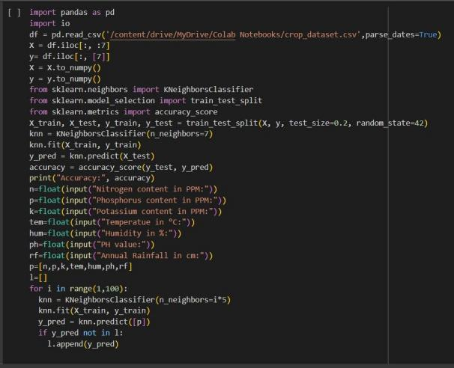

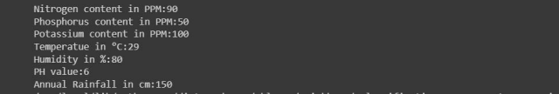

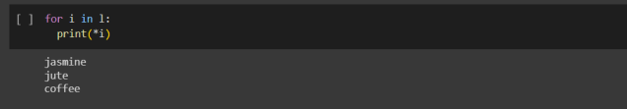

The output describes the predicted crop for the given input features (humidity, temperature, time, NPK value and rain) to the KNN model.

**5. 2 PROGRAM WITH OUTPUT OF RANDOM FOREST ALGORITHM**

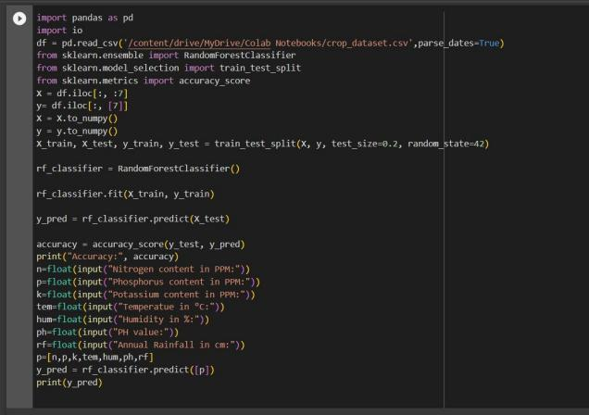

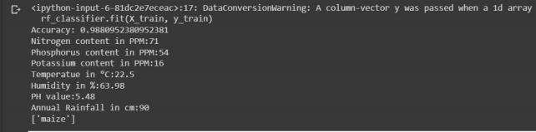

The output describes the predicted crop for the given input features (humidity, temperature, time, NPK value and rain) to the Random Forest model.

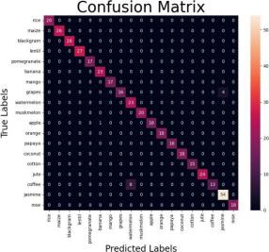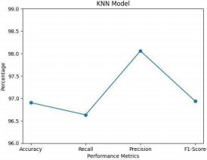

5.3 EVALUVATION AND ANALYSIS BETWEEN THE ML ALGORITHMS Random Forest Algorithm KNN Alogrithm

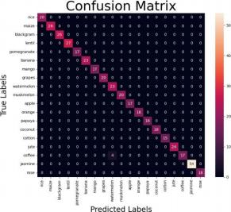

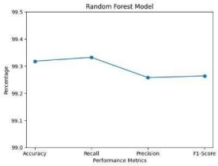

*FIG: 5.3.3: GRAPH BTW PARAMETERS FOR RF AND KNN*

Table for parameter analysis of RF Table for parameter analysis of KNN

|  |  |  |  |  |
| --- | --- | --- | --- | --- |
| Performance Metrics | Random Forest Model |  | Performance Metrics | KNN Model |
| Accuracy | 99.04% | Accuracy | 96.90% |
| Precision | 98.99% | Precision | 96.63% |
| Recall | 99.22% | Recall | 98.05% |
| F1-Score | 99.02% | F1-Score | 96.93% |

**CONCLUSION**

As a conclusion, this project have achieved the main objective. The proposed system helps the farmers to choose the right crop by providing insights that ordinary farmers don't keep track of thereby decreasing the chances of crop failure and increasing productivity. It also prevents

them from incurring losses. It will be beneficial not only to the farmers but others too.

As technology advances other factors can be added that can result in more accurate crop selection for the farmers. In order to feed a rising world population, new technology in the agricultural industry needs to be implemented. Apart from this, agriculturists need a proper guideline in time that will allow them to forecast crop yields so that they can formulate effective strategies to maximize crop yields. This paper will presumably pave the groundwork for extensive research on how crop yield prediction work.

**REFERENCE**

[1] Kumar, Aayush, Omen Rajendra Pooniwala, and Swapneel Chakraborty. Intelligent Crop

Recommendation System Using ML. Diss. CMR Institute of Technology. Bangalore, 2020.

[2] Reddy, D. Jayanarayana, and M. Rudra Kumar. "Crop yield prediction using machine learning algorithm." 2021 5th International Conference on Intelligent Computing and Control Systems

(ICICCS). IEEE, 2021.

[3] Sharma, Manish Kumar, et al. "Crop Selection Using Data Analytics." 2020 2nd International Conference on Advances in Computing, Communication Control and Networking (ICACCCN). IEEE,

2020.

[4] Tobing, Dema Mathias Lumban, Julia Kurniasih, and Yulius Nahak Tetik. "The Prototype of Decision Support System For Selecting The Lands of Crops." 2019 4th International Conference on Information

Technology, Information Systems and Electrical Engineering (ICITISEE). IEEE, 2019.

[5] S. R. Rajeswari, ParthKhunteta, Subham Kumar, Amrit Raj Singh, Vaibhav Pandey, "Smart Farming Prediction using Machine Learning", International Journal of Innovative Technology and Exploring

Engineering, 2019, Volume-08, Issue-07.

[6] Z. Doshi, S. Nadkarni, R. Agrawal, and N. Shah,"Agro Consultant: Intelligent Crop Recommendation System Using Machine Learning Algorithms”, Fourth International Conference on Computing Communication Control and Automation (ICCUBEA), Pune,India, 2018, pp. 1-6, DOI:

10.1109/ICCUBEA.2018.8697349.

[7] S. Pudumalar, E. Ramanujam, R. H. Rajashree, C. Kavya, T. Kiruthika and J. Nisha, "Crop recommendation system for precision agriculture," Eighth International Conference on Advanced

Computing (ICoAC), 2017,pp. 32-36, DOI: 10.1109/ICoAC.2017.7951740.

[8] Konstantinos G. Liakos, Patrizia Busato, Dimitrios Moshou, Simon Pearson and Dionysis Bochtis, “Machine Learning in Agriculture: A Review”, Article on sensors, 2018, pp 1-29,

doi:10.3390/s18082674.

[9] M. T. Shakoor, K. Rahman, S. N. Rayta and A. Chakrabarty, "Agricultural production output prediction using Supervised Machine Learning techniques”, 1st International Conference on Next Generation

Computing Applications (NextComp),

Mauritius, 2017, pp. 182- 187, DOI: 10.1109/NEXTCOMP.2017.8016196.

[10] Marion Olubunmi Adebiyi, Roseline Oluwaseun Ogundokun and Aneoghena Amarachi Abokhai, "Machine Learning-Based Predictive Farmland Optimization and Crop Monitoring System", open-

access article distributed Volume 2020, pp 1- 12,<https://doi.org/10.1155/2020/9428281>.